Impactful Resilient Infrastructure Science and Engineering
(IRISE)
-Project Scope of Work-
(FY 2023-24 (IRISE Year 6) Annual Work Program)

SUMMARY PAGE
Project Title: Why do they keep sliding? Analysis of Reoccurring Landslides in SWPA to Advance Hazard and Risk Estimates
Person Submitting Proposal: Daniel Bain, Eitan Shelef, Anthony Iannaccione

Proposed Funding Period: May 1, 2024 – April 30, 2025

Project Duration: 12 months

Project Cost: $160,007.72

Project Title: Why do they keep sliding? Analysis of Reoccurring Landslides in SWPA to Advance Hazard and Risk Estimates

Problem Statement: Landslides often disrupt road networks and infrastructure in southwestern Pennsylvania (SWPA). Historically, landslides are common in SWPA due to the combined effects of geologic and climatic conditions (including changing climatic conditions and associated flooding of waterways), rugged hillslopes, and human modification of the landscape. Recent efforts to construct a regional landslide database have revealed that in some areas, reoccurring landslides tend to occur on top of historical landslides, or adjacent to previous landslides. Sometimes reoccurring landslides develop after landslides in the same location are repaired. In contrast, in other areas, reoccurring landslides are very rare. Given that reoccurring landslides are an important type of landslide in SWPA, understanding the environmental aspects (e.g., topography, lithology, precipitation/climate change, flooding events and saturation of slope or erosion of toe of slope ) and human (e.g., land use/land cover, mining) factors that favor such reoccurrence can help identify elevated risk areas for reoccurring slides and improve mitigation efforts.

Project Objectives: Identify the key factors and processes that govern landslide reoccurrence in SWPA. Identify interactions between these factors and human landscape modifications that influence reoccurrence. Identified factors will guide estimates of relative risk levels associated with potential landslide reocurrence and direct recommendations for effective identification, as well as recommendations for preventative and/or remediation efforts for reoccurring landslides.

Project Scope: To identify these key factors and the underlying processes, the project will analyze data from a recently constructed regional landslide database in combination with topographic and lithologic maps, precipitation data, aerial photography, and field site visits, as well as guidance from experts and landslide reports. Specifically, we will complete the following project components:

- Conduct initial spatial analysis to document “new” and “reoccurring” landslides across SWPA in the context of geologic, topographic, climatic/hydraulic (saturation of slope or scour), and land-use/land-cover factors. This analysis will aim to delineate regionality in landslide pattern and process. Representative landslides with comprehensive geotechnical data will be identified; particularly those demonstrating continued movement over time, including repaired landslides (with type/mechanism of repair), and landslides reoccurring following remediation.
- Develop feasible conceptual mechanistic models of landslides with and without documented reoccurrence, based on the recent scientific and technical literature and in consultation with experts and the advisory board. Obtain/supplement available geotechnical data from published sources or from geotechnical investigations associated with current remediation, as needed.
- Use comparative multivariate analysis of stable slopes vs. new landslides, and new landslides vs. reoccurring landslides to identify the primary differences in environmental factors (e.g., topography, lithology, climatic/hydrologic, land use/landcover) between these groups and evaluate their role and associated risk (within data and method limitations) for landslide occurrence. The factor evaluation process will be guided by the conceptual mechanistic models, which will help identify model(s) that best correlate with the database and data for new and reoccurring slides.

The results of this analysis will identify which key landslide characteristics/factors interact to drive the mechanistic processes of landslide reoccurrence, help identify slides with high probability of reoccurrence where more comprehensive repair methods are justified, and provide recommendations for the most economic and effective remediation and mitigation for reoccurring slides.

Task Statements: The objectives of this project will be realized through the completion of the following tasks:

Task A: Establish working group of IRISE members (consisting of both current members and new members) and conduct monthly/bi-monthly meetings to review and discuss research findings, progress and recommendations.
Given the broad spatial scale and the complicated drivers contributing to landslide reoccurrence, exploration of this phenomena benefits from sustained input from professionals who face landslide–related challenges and the influence on landslides on infrastructure. We will invite IRISE members to participate, leveraging their experience and input on the research findings, as well as considerable reach into the local geophysical community to help guide the design and focus of the analysis. Meetings will be held at a monthly to bimonthly frequency for the entire project period. In general, during these meetings, the project team will report on progress of the research and emerging challenges. We will solicit input from the working group through structured discussion. Research findings and any recommendations will be provided to members for review in advance of the meetings, as possible, to facilitate input.
Fundamentally these meetings will be a primary communication tool. These meetings will offer regular opportunities to ensure progress and communicate interests and insights while minimizing the impact on schedules and resources of IRISE partners.

Task B: Initial spatial analysis

Identifying the locations and environmental factors (geology, topography, climate, hydraulics and land-use/land-cover) that are associated with landslide reoccurrence can further understanding of factors with greatest associated risk and point toward mitigative strategies to prevent reoccurrence. To identify these locations and conditions, we will rely on the regional landslide database constructed as a part of the Landslide Database research and conduct initial spatial analysis that will document recent landslide events and “reoccurring” landslides across SWPA in the context of environmental factors. This analysis will delineate regionality in landslide pattern (e.g., differences among PennDOT districts) and be used to identify representative “type” landslides, particularly those with comprehensive geotechnical data.

Task C: Conceptual mechanistic models
A set of conceptual mechanistic models for landslide reoccurrence can guide the search for key environmental factors that drive reoccurrence. Guided by the initial spatial analysis, a review of the scientific and technical literature, local geotechnical reports, and field visits to representative “type” landslides identified in Task B, we will develop conceptual models in consultation with the working group. The model(s) will guide comparative analysis (Task D) focused on key factors that cause landslide reoccurrence, and the models and determined key factors will be updated based on the results of this analysis.

Task D: Comparative multivariate analysis of reoccurring, stable, and new landslides

Comparative analysis of reoccurring landslides, recent landslides that achieve stability post landslide, and stable slopes can help identify the primary differences in environmental factors between reoccurring slides and non-reoccurring (stable) slides, and aid in the development of representative mechanical models for landslide reoccurrence. The factor evaluation process will be guided by the conceptual mechanistic models. Identification of factor importance will also help refine the models to better match the field data from slides. These analyses, which explore the environmental factors affecting slides, will clarify how, and which, key factors interact to drive the mechanistic processes affecting landslide reoccurrence. Further, the analyses will indicate specific areas or specific contributing factors where the probability of landslide reoccurrence is such that more comprehensive (and expensive) repair methods are justified. Recommendations will be provided for remedial actions for reoccurring slides based on the controlling factors and mechanistic models.

Task E: Draft Final Report
We will repair a draft final report to document project activities, the literature review, findings, and recommendations. The draft final report will include recommendations for identifying areas prone for landslide reoccurrence, recommended analysis and/or mitigation efforts or repairs for recurrent slides, and conceptual mechanistic model(s) that may explain landslide reoccurrence in SWPA. We will submit the draft report to the working group members for input and comments.

Task F: Final Report

A final report that takes into consideration comments on the draft final report will be submitted.

Deliverables:
The following deliverables will be provided based on completion of the above tasks:
- Deliverable #1 – Minutes from the Working Group meetings will be shared with IRISE leadership and the PennDOT Research Project Manager following each meeting.
- Deliverable #2 – A map of reoccurring landslides in SWPA and documentation of field visits will be submitted to IRISE and the PennDOT Research Project Manager within 6 months from the notice to proceed date.
- Deliverable #3 – A draft final report will be submitted to IRISE and the PennDOT Research Project Manager within 11 months from the notice to proceed date.
- Deliverable #4 – The final report will be submitted to IRISE and the PennDOT Research Project Manager within 12 months from the notice to proceed date.
Upon completion, deliverables will be submitted to PennDOT.

Budget Notes
Key Personnel:
Principal Investigator: Daniel Bain
Other Key Staff: Eitan Shelef, Anthony Iannacchione

Other Personnel:
Grad Students: Emrah Ozpolat, Abiodun Ayo-Bali
Non-Personnel:
Supplies:
$1,000.00 is requested for the supplies below:
- Project Incidentals

Proposed Person-Hours by Task:

Team Member | Task A | Task B | Task C | Task D | Tasks E/F | Total
Key Project Team Members, Estimated Hours Per Task
Eitan Shelef | 10 | 30 | 40 | 50 | 40 | 170
Daniel Bain | 10 | 30 | 40 | 50 | 40 | 170
Anthony Iannacchione | 10 | 20 | 50 | 30 | 25 | 135
Emrah Ozpolat | 3 | 150 | 100 | 300 | 140 | 693
Abiodun Ayo-Bali | 3 | 150 | 100 | 300 | 140 | 693
Total | 36 | 380 | 330 | 730 | 385 | 1861

Schedule:
Calendar Year | Year 1 |  |  |  | Year 2
Quarters | Q1 | Q2 | Q3 | Q4 | Q1 | Q2 | Q3 | Q4
Task A: Establish working group and convene monthly meetings
Task B: Initial spatial analysis
Task C: Conceptual mechanistic models
Task D: Comparative analysis
Task E: Draft final report
Task F: Final report

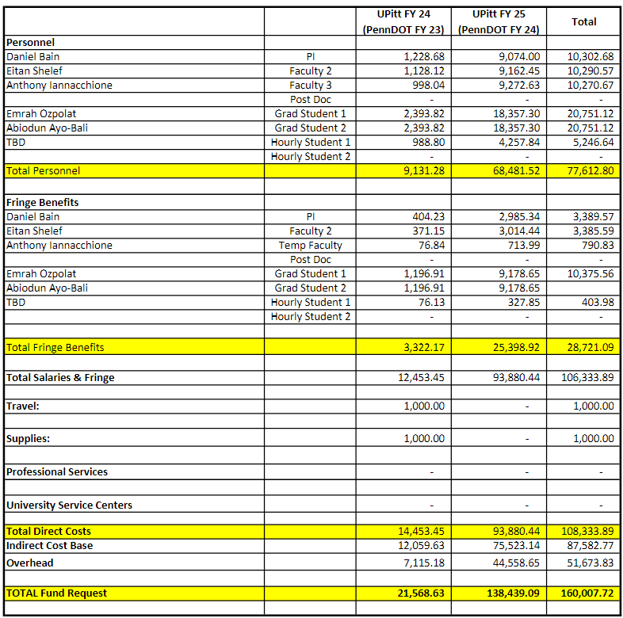
Budget: The total project cost is $160,007.72


Acknowledged By:

Daniel Bain
Principal Investigator

