Netzsch Thermomechanical Analyzer 402 F1

Basis Operation Procedure

Attention:
Use Globes + tweezer.
Do not swing the furnace.
Check the Nitrogen gas and do not change the gas pressure.
The temperature program used in Correction measurement and Correction + sample measurement should be the same.
Sample should be flat. Check the sample size, melting point of the sample and the test temperature.
Maximum Length: up to 25mm
Maximum diameter: up to 10 mm
Maximum force: 0.2N

General information
Power switch – Instrument “on/off”. Behind the instrument.
Correction sample - High purity aluminum oxide
Correction sample dimension: 6mm dia., 25mm length (mentioned on the back of sample box)
Furnace temperature range: RT- 1550°C (Recommended temperature- up to 1400°C)
Heating rate- 50 K/min
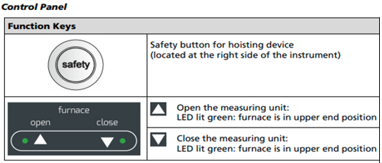
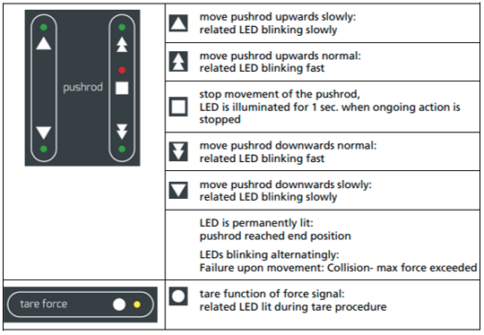
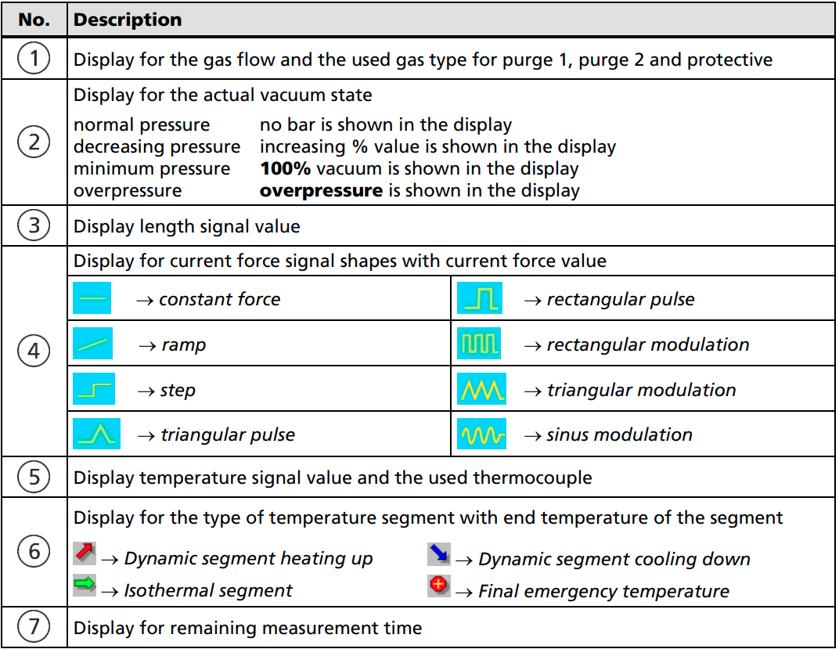 | 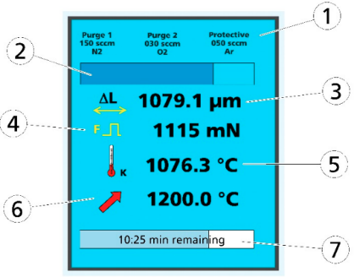

Procedure-
- Opening the instrument
- Inserting the standard sample
- Closing the instrument
- Turning on the gas
- Entering measurement parameters
- Starting the program
- Saving the measurement file
- Opening the instrument and taking out the sample
- Inserting the tested sample and closing the instrument
- Entering measurement parameters
- Starting the program and saving the file
- Finishing the measurement

1. Opening the instrument

Pressing “Open button+ Safety button” simultaneously moves the furnace into the upper end position (Green LED nest to the open button lit) | 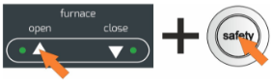

2. Inserting the standard sample

Note: Sample should be flat. If not, it might be tilted.
- Move the pushrod downwards to get enough space between pushrod and top to set up the sample.  - Set up the sample carefully in the center of pushrod using tweezers.  - Move pushrod upwards normal for a while using button and stop using button when it closes to the top.  - Move upwards slowly using button. Stop itself when it touches at the top where is a little flat spot.  - Move pushrod down slowly using button (a little bit) and up slowly using button. Make twice to ensure the balance of the force to the sample. | 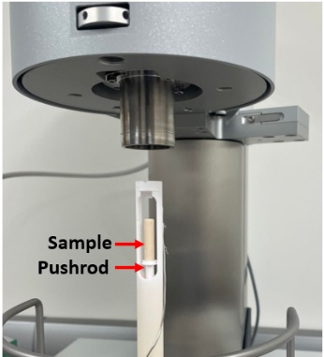
Note: ΔL is no force no expansion at this state but some smaller force is shown in display due to contacting with the top.

3. Closing the instrument
- To close the instrument, swing the furnace to the middle position.  - Pressing “Close button+ Safety button” simultaneously moves the furnace into the lower end position (Green LED next to the open button lit) | 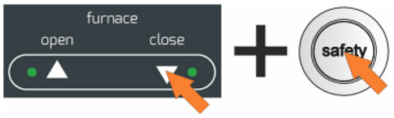

4. Turning on the gas
Check the nitrogen gas and turn it on. Do not change the pressure.

5. Enter Measurement Parameters (Run a measurement)
Open the computer, Password “nopass”. Open the software 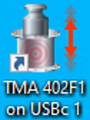 .
There are 2 types of measurement. I. Correction and II. Correction +sample.

I. Measurement type- Correction
If you want to run a correction measurement: Make New file.
Define your measurement program. (Set up, Header, Calibration standard, Temperature program, Calibration, Last items)

- Set up (Check instrument configuration)
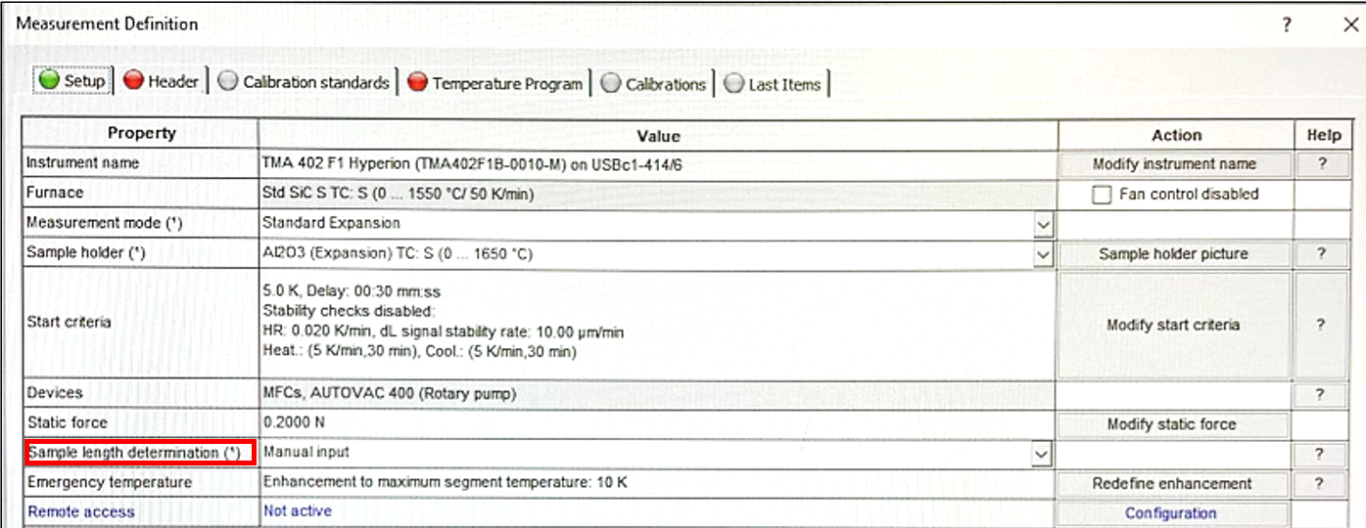
- Sample length determination: Select Manual input.
- Click on Forward-> or click on Header.

- Header
- Select measurement type: Correction
- Define the standard sample: Identity, Name, Shape, Size, and Material.
- Define MFC gases (Purge/protective): Purge 2 MFC-Nitrogen, Protective MFC-Nitrogen
- Click on Forward -> or click on Calibration standard.

- Calibration standards
- Select temperature calibration (if require). OR
- Select table of calibration standard. (C:\NETZSCH\Proteu80\_Records\cal\Al2o3ne.sd)

- Temperature Program
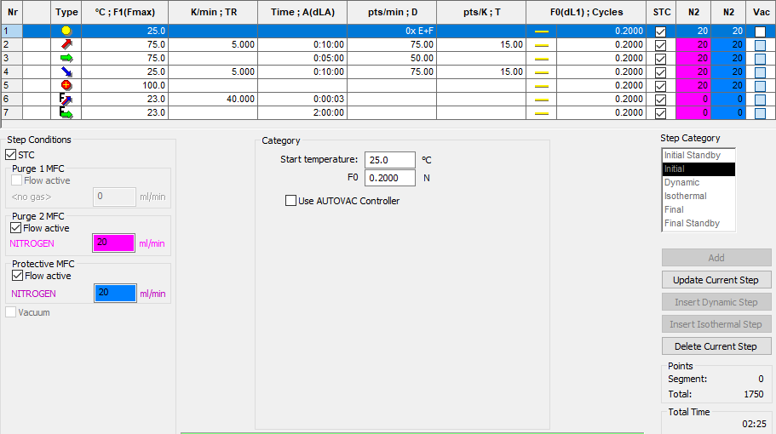
- Define all steps of temperature program.
- Select step category (Initial, Dynamic, Isothermal, Dynamic, Final, Final stand-by)
- Click on ‘Add’ after adding the numbers for each category and then go to the next category.

- Calibration
Check temperature calibration will not be used.

- Last items (Define file name)
Save the correction file in C:\NETZSCH\Proteus80\data.

Click Measure. The program switches to the adjustment window. Before the program starts, all measurement definition should be green.

6. Starting the program
- Choose DIL-5000um, Offset- standard or choose one depends on the sample and click on Set initial force gases to check the gas - click Yes, and then Start the program.  - NGB Measurement box will come up. Click OK.  - You can also check your program on the display area of the furnace while the process is running condition.  After completing the running process, Click on Measurement in the menu and select Stop stand by.  Wait for a while to complete the process. | 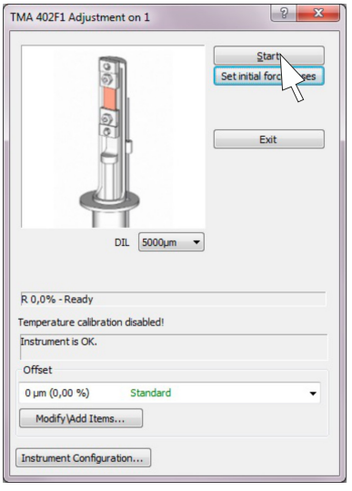
7. Saving the measurement file
- Click on the Extra on the menu bar, select Run Analysis program.
- Netzsch Proteus Thermal Analysis 8.03 window comes up.
- Click on the Extra on the menu bar and select Export data. Choose Click on the Export on the measurement data and save the file.

8. Opening the instrument and taking out the sample
- Before opening the furnace, cool down the sample or the furnace temperature should be under 50°C.
- Follow the procedure mentioned in section 1. Opening the instrument
- Move the pushrod downwards using to get enough space between pushrod and top to take out the sample.
- Take out the sample carefully using gloves and tweezers.

9. Inserting the sample and closing the instrument (Sec. 2 &3)
- Set up the sample carefully in the center of pushrod using tweezers.
- Move pushrod upwards slowly. Stop itself when it touches at the top where is a little flat spot. Move pushrod Down (a little bit) and up. Make twice.
Note: Sample should be flat. If not, it might be tilted.
- Follow the procedure mentioned in section 3. Closing the instrument

10. Entering the program parameters
II. Measurement type- Correction + Sample

If you want to run a correction + Sample measurement: Click on File and then select used file from standard correction measurement (Open circle file) and Open.
Define your measurement program. (Fast definition, Set up, Header, Calibration standard, Temperature program, Calibration, Last items)
Note: You can set up your measurement program in Fast definition only.
- Fast definition
- Select measurement type: Correction +sample
- Click Get them to accept properties of just open measurement OR
Click Reset them to define new properties and setting: Identity, Name, Shape, Size, Material
e.g. Dimension of the sample- 6.36mm x 6.36mm x 12.34mm (cubic)
- Click on Select to save the file in C:\NETZSCH\Proteus80\data.
- Click on Forward -> or Measure.
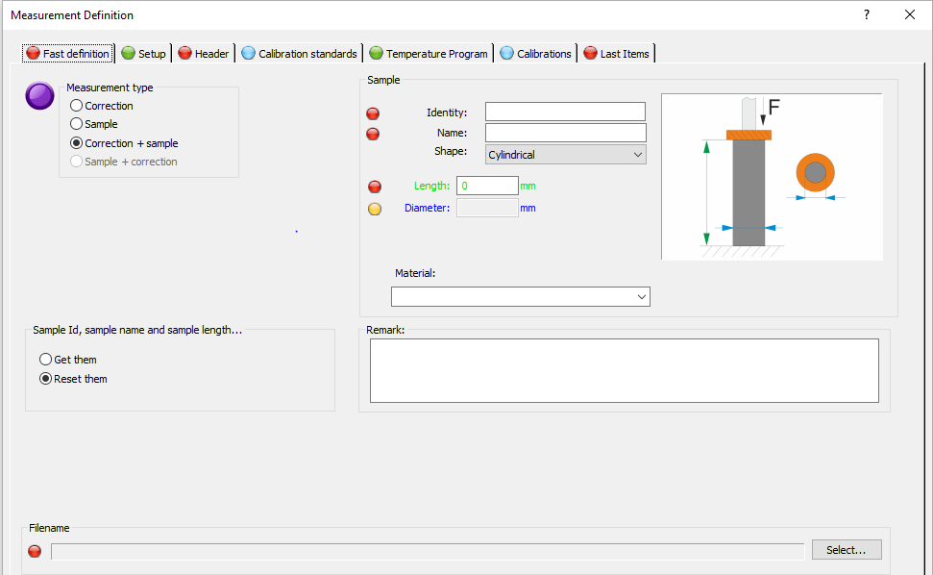
Note: You can see that the rest of measurement definitions are green (Set up, Header, Temperature program, Last items)
The temperature program must be identical to the just opened temperature program.

Calibration standards
Select table of calibration standard. (C:\NETZSCH\Proteu80\_Records\cal\Al2o3ne.sd)

Calibration
Check temperature calibration will not be used.

11. Follow the procedures mentioned in sections:
6. Starting (measuring) the program
7. Saving the file

12. Finishing the measurement
Follow the procedures mentioned in section 8. Opening the instrument and taking out the sample, and
3. Closing the instrument

Turn off the gas after testing. Don’t turn off the pump and water-cooling system.

