Netzsch Laser Flash Analyzer 427
Basic Operation Instruction
- Turn on air cooling apparatus.
- Filling the liquid nitrogen.
- Sample preparation
- Setting up the sample.
- Purging with helium.
- Dynamic operation
- Operate the instrument.
- Evaluation of the Measurement

I. Turn on Air cooling apparatus.
- Switch on the air-cooling apparatus in Room 507.
- Close the room door.
- Check 2 green lights at the water flow regulator box behind the LFA cell.
II. Filling the liquid nitrogen.
- Use liquid nitrogen container, goggles, and gloves.
- Use the back elevator or stair to go to SB floor when bringing liquid nitrogen.
- Fill your ID, amount of liquid nitrogen-1 liter, and reason- LFA running test, MMCL, in the form.
- Fill the liquid N₂ ½ of the container (about 1 min).
- Filling liquid nitrogen to the LFA.
- Remove the top cover of the instrument, use funnel, and fill the liquid nitrogen using glove and goggle.
- Close the top cover.
- Wait for 15 mins.

III. Sample preparation (Detailed -Page 100)
- Samples must be plain and parallel faces.
- Use a micrometer to measure the sample thickness at least three times at the middle part of the sample.
- Calculate the average of the three measurements and use this value for the thickness.
- The optimum sample thickness is 1.5 mm up to 2.5 mm for the recommended sample diameter of 12.6 mm.
- Low thermal conductivity samples should not exceed 2.5 mm and samples with high thermal conductivity should not be less than 1.5 mm.

Graphite coating
It is recommended to apply graphite-spray under an exhaust hood with adequate air flow to avoid inhalation of aerosols.
1. Clean all samples with a suitable solvent (including the reference sample if it has been graphite coated previously).
2. Shake spray can (min. 1 minute; vertical as well as horizontal).
3. Before coating the sample, spray next to the sample three times for less than 1 second
4. Hold the spray can in a distance of approx. 20-30 cm (10-12 inches) away from the sample. Fully depress the valve aiming to one side of the sample for less than 1 sec. to initiate the spray. Maintain a constant distance to apply an even thin coat.
5. Wait approx. 2 min. for the coat to dry.
6. Repeat steps 2-4 one or two times if necessary.
7. Turn the sample over, taking care that the coating of the sample faces will not be damaged.
8. Sample must be fully coated uniformly to absorb heat uniformly.

Check the valves.
- Close the sample chamber gas inlet valve on the measuring part 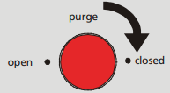
- Close the sample chamber gas outlet valve on the left side of the furnace.
- Close the shut-off valve on the gas inlet of the furnace chamber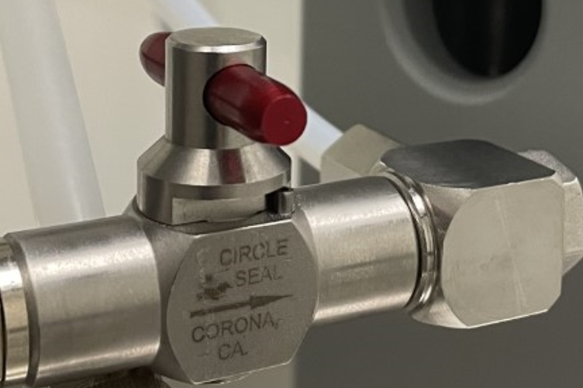 behind the furnace.

IV. Setting up the sample.
- Wear gloves.
- Turn on both controllers.
- Check 2 pressure displays on the left side of the LFA cell, they must be ‘0’pressure. If not, turn the valves to get pressure ‘0’. 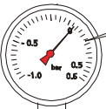
- Turn the clamp anticlockwise about 60° to open the furnace.
- Raise the hosting device (upper part) by pressing the safety button and up arrow in LFA cell.
- Slowly move the furnace from the top of the sample holder to the left side.
- Remove the sample cover and sample holder.
- Put the sample carefully into the sample holder.
- Cover back the sample.
- Slowly move the furnace back on the top of the sample holder.
- Press the safety button and down arrow to move down the furnace.
- Tighten the clamp (Turn clockwise) and align it as marked.

V. Purging with helium
A. Evacuating the sample chamber and furnace.
- Turn on the valve of the helium gas cylinder.  - Switch ‘operation mode’ to Vacuum (pump on) using in safety control system (S.C.S).  - Open the upper angle valve 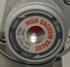 (red) first slowly and to the end to evacuate the sample chamber to approx. -1 bar. | 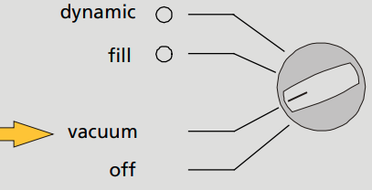
- Open the bottom angle valve 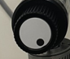 (black) first slowly and to the end to evacuate the furnace to approx. -1 bar.
- Wait until the pressure displayed on the pressure gauge has stabilized. (5 mins).
B. Filling gas
- Close both angle valves.

Set the switch on the S.C.S. to fill position (LED lights green). The vacuum pump stops automatically. | 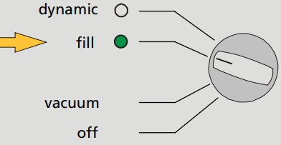
2a. For Sample chamber
- Slowly switch the gas inlet valve to position open 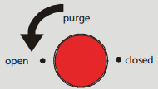 at LFA cell. Open 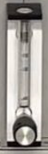 and adjust the flow meter between 70-100 if necessary.
- If the pressure display of sample holder shows ‘0’ (Red), close the gas inlet valve .
2b. For Furnace
- Turn on the valve 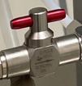 till the pressure display shows ‘0’ to fill the gas to furnace until pressure compensation has been reached. Then turn off the valve
- Repeat the evacuation and filling procedure twice.

VI. Dynamic operation
At the Filling step in the third time,
- Close both angle valves.

Set the switch on the S.C.S. to fill position (LED lights green). The vacuum pump stops automatically.

2a. For Sample chamber
- Slowly switch the gas inlet valve to position open at LFA cell. Open and adjust the flow meter between 70-100.
- Introduce gas up to a slight overpressure (watch the pressure gauge)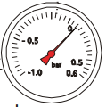
- The gas inlet valve remains in position open after the third filling.
- Turn on the sample chamber gas outlet valve on the left side of the furnace.
2b. For Furnace
- Turn on the valve to introduce gas up to a slight overpressure (watch the pressure gauge).
- The gas inlet valve remains in position open after the third filling.
- Set the switch to dynamic position (LED lights green).
- Check the display of the gas flow rate (green light 75% of the LED bar as marked)
a. 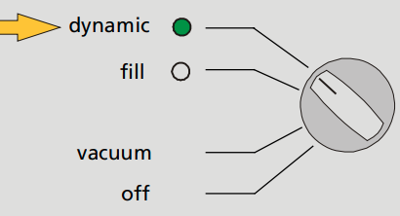 b. 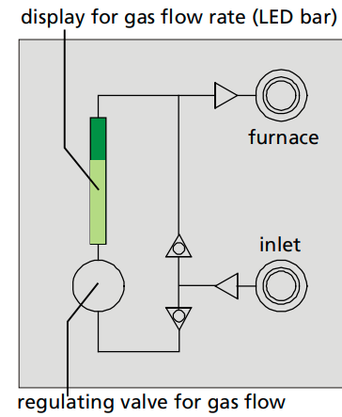

VII. Operate the instrument. (Detailed instruction -Page 110 in Manual)
- Open the software 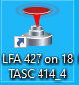.
- Click Instrument Setup in the File menu and check the setting. Choose the Centering cone. Then press OK.
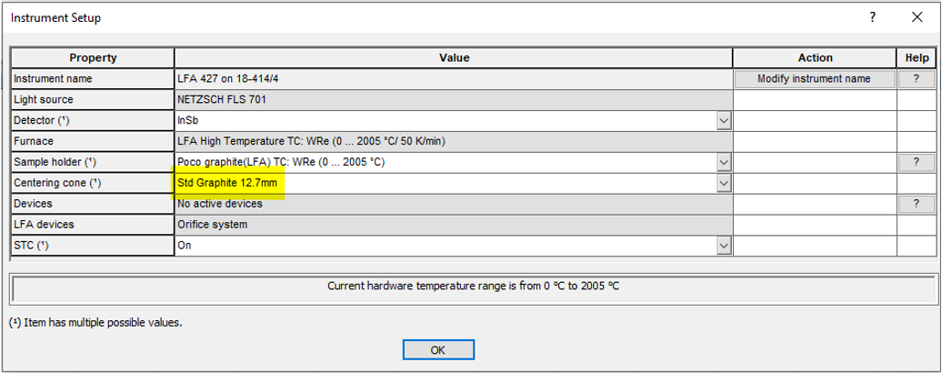
- Click on Measurement to create a new file.
- Enter parameters. Click into the lines where the parameters are to be defined. (General, Sample, Initial Conditions, Temperature steps, Final Conditions). Continue with Next.
For Example
- General
Identify- TC/TD/SH  Operator- Khaing Khaing Aye  Customer- User  Laboratory- MMCL  Remark – Training | Detector – InSb  Centering Cone- Std Graphite 12.7mm  Ratio- 0.7  Use Temperature Calibration
- Sample
Name- Training George
Coating- graphite
Diameter -12.7mm
Sample Type- Single layer
Material- Pyroceram 9606
Thickness – 2.5mm

- Initial Conditions
Laser Voltage- 600V
Pulse Width- 0.3ms.
Atmosphere- He
Flow rate -100ml/min. Read the flow rate on the control panel.

- Temperature Steps
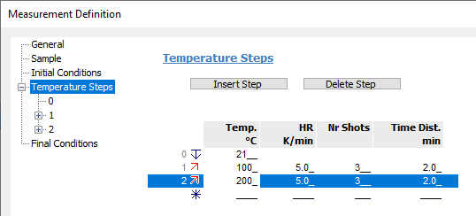

- Final Condition
Emergency Reset Temp- Add +50C to your measuring temperature.
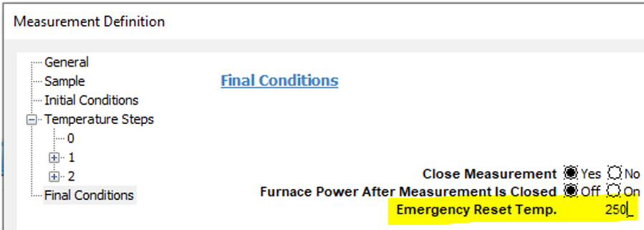

- Click OK after entering the final conditions.
- Click the key to start the measurement at the display bar.

VIII. Evaluation of the Measurement (Detailed instruction-Page 119 in Manual)
- Open the NETZSCH-Proteus group .
- Select the Proteus LFA Analysis .
- Click Load/Unload in Tool bar.
- Open the respective database file. Click on Load.
- The measurement file is shown in the analysis program.
- To change the calculation model, select Calculate thermal conductivity in the calculation menu. Check mark to the analysis which you want. Click OK
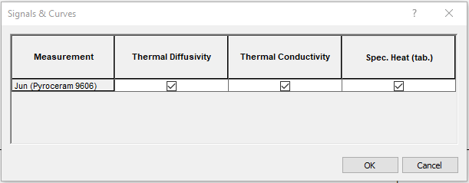
VIII. Finishing
- Close the valves.
- Close the sample chamber gas inlet valve on the measuring part
- Close the sample chamber gas outlet valve on the left side of the furnace.
- Close the shut-off valve on the gas inlet of the furnace chamber behind the furnace.
- Turn off the Helium gas.
- Switch off both controllers.
- Turn off air cooling apparatus in Room 507, turn off the light and close the door back.
- Don’t forget to log off from FOM.

