Profilometer-Bruker Contour GT-I
Basic Operation Instruction
Warning:
- Ensure that there is no object on the scanning stage before setting up the microscope.
- There must be enough space between lens and stage to set up the sample.
- Use the glass plate to prevent dirt on the stage when handling small samples.
- Don’t forget to log off from the FOM after finishing.
Procedure
- Starting
- Measurement Set up
VSI/VXI measurement (Rough sample- 0.3-5nm)
PSI measurement (Smooth sample- step height <0.3nm)
- Looking for fringes and optimize fringes (Focus the sample)
- Measurement and data analysis
- Saving the Data
- Changing the sample
- Finishing

I. Starting
- Open the software 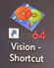.
- Wait for the initialization of the stage and follow the instructions.
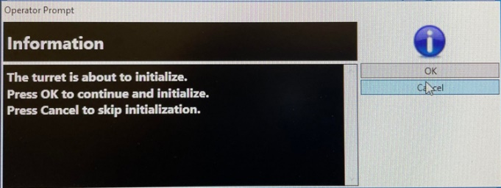 Click OK
Click OK

Overview of the screen
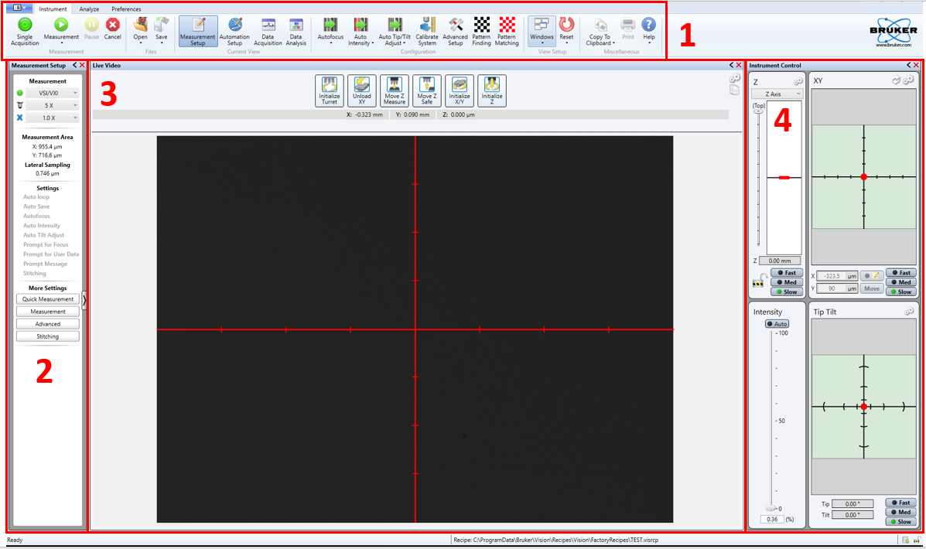
- Tool bar- To set up overall system configurations.
- Measurement - To commend the system using measurement parameters.
- Live video- To find the fringes and adjust the fringes.
- Instrument control-To control XY position, Z position, Tip and Tilt, and light intensity.
Note: We can control the XY position, Z position, and Tip and Tilt using control box. We can also use the light control box.
- Turn on the control box. (Don’t turn off the control box after completing the test).
- Set up the sample on the stage.

VSI/VXI measurement (Rough sample- 0.3-5nm)
II. A. Measurement Set up
- Measurement- Choose VSI/VXI
- Start with the objective lens 5x and field of view lens 1.0X.
- Click on Measurement, and choose Measurement Parameters
- Speed-1X
- Back scan and Length – Choose 20um and 50um, respectively. The total movement of the objective lens will be 70um. Depends on sample step height.
- Threshold- Use between 7-15% .
- Illumination- Check Use default (white for VSI measurement)
- Average- Check Average and choose 2 or 3 as you desire.
- Check Enable (End scan 5um after 90%) to save time.
- Processing method- Choose Type VSI
III A. Looking for fringes and optimize fringes.
Note: Fringes are localized around the best focus.
Looking for fringes
- Turn on the auto intensity to see the sample.
- Control the sample position using a control box or mouse on Instrument Control area.
3 options to move the sample using fast, Medium and slow speed. 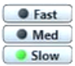
Z profile is for X direction. Pull up/down the red dot to away/close to the sample.
X profile is for X direction and Y profile is for Y direction. Pull the red dot to X or Y direction.
- Go to edge of the sample to adjust the focus of the image. Can see the fringes when the image is on sharp focus.
- Double click the point that you want to measure. That area will be moved into the center of the crosshair line.
- When you get fringes, change the objective lens and field of view lens to get desired magnification.

Optimize fringes
Note: The white light, Zero order fringes are the highest contracts.
- Use red dot in Tip Tilt to rotate and adjust the number of the fringes.
- Fringes should be perpendicular position. (Spin Red dot in Tip Tilt to get the right position).
- Standard fringes number-3 to 5 Nos.(Pull the red dot up direction to shrink the fringes and down direction to expand the fringes).
- Redo Auto Intensity.

IV. Measurement and data analysis (Term removal, Step height)
- Click on Measurement on Tool bar.
You can see Surface height, Data and Grayscale Data in Data analyzer (Right side of the screen)  - Click on Data.  - Choose Term Removal (F-operator) under 3D Filter from Analysis Toolbox (Bottom Right side of the screen)  - Choose Step Height under 3D analysis section from Analysis Toolbox | 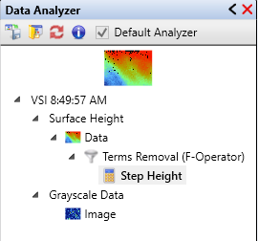
- Data Analysis screen will come up under Instrument setting.
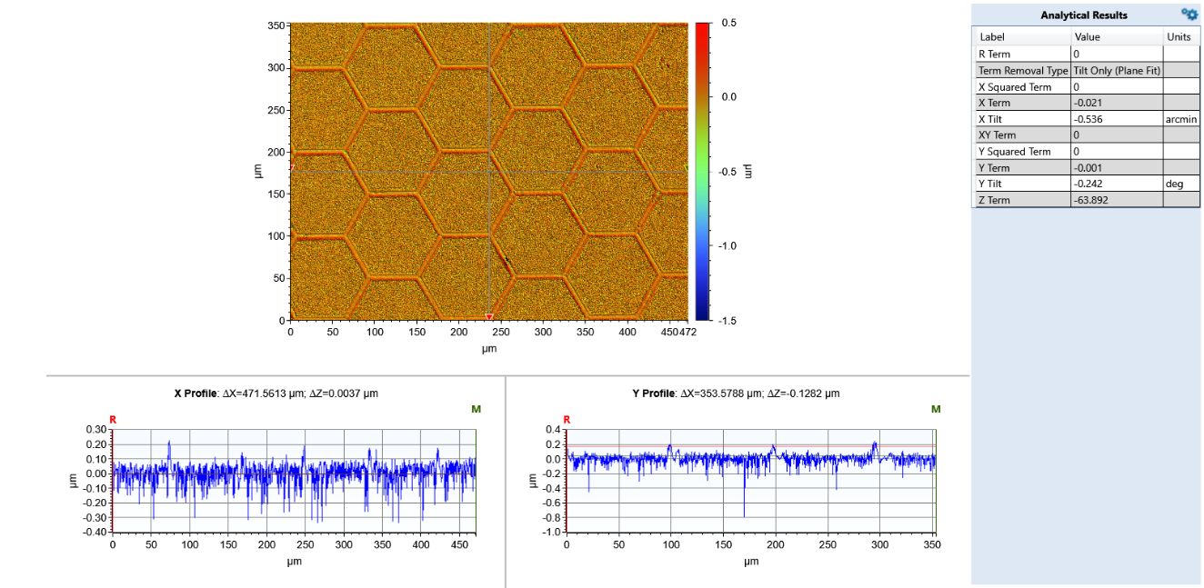
Note: Adjust the measurement line using arrow that you want.
1. Edit Mask
- Right click on Term Removal (F-operator).
- Choose Edit settings.
- Term Removal box will come up.
- Choose Tilt only (Plane fit). Click Edit Mask.
- Select the tool shape>select the region> make the region on the image.
Click on Mask, invert Mask then click on OK.
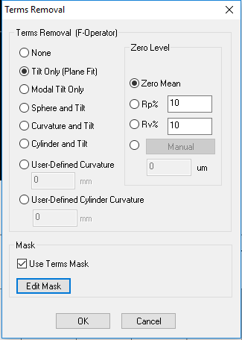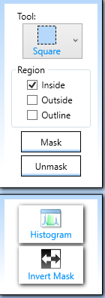
2. Step Height measurement -Click on Step height to get the results.

V. Saving the Data
- Save the file in C:\Program Data\Bruker\Vision\Data\Your Folder
- To save 3D profile file
Click on 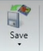 button, choose Dataset. Save the data with (*.OPDx) type.

- To save analysis and measurement parameters

Click on Save button, choose Vision Recipe. If the below window will pop up
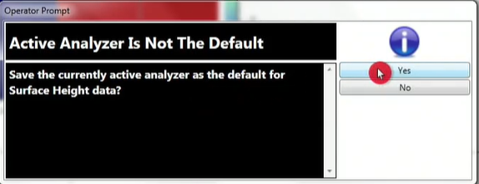 Click Yes.
- Save in C:\Program Data\Bruker\Vision\Recipes\Vision\Your Folder.
Save the data with (*.visrcp) type.
Recommend: After getting all results, transfer your results to DATA_ Share$ Folder.
Use MMCL server computer in room 532b to get your data by Flash drive. Password (532b).
VI. Changing the sample
- Click on Measurement Setup in the Tool bar.
- Change the Lens 5X.
- Pull up the Red arrow in Z axis using Fast speed and to get enough space between lens and stage to remove the sample and to set up the new sample.
- Change the sample.

- Finishing
- Click on Measurement Setup in the Tool bar.
- Change the Lens 5X.
- Pull up the red arrow in Z axis using Fast speed and to get enough space between lens and stage to remove the sample.
- Make sure save the results before exit the program.
- Exit the program.
- Take the sample and clean the stage.
- Turn off the light box.
- Don’t turn off the control box after completing the test.
- Log out from the FOM.
Log in to MMCL server computer and get your results from Data Share$ Folder.
Analysis Software - Gwydion

PSI measurement (Smooth sample- <0.3nm)
II B. Measurement Set up
- Measurement- Choose PSI
- Start with the objective lens 5x and field of view lens 1.0X.
- Measurement parameters
Threshold- 7%
Illumination- Check Use default (Green for PSI measurement)
Average- Can choose 2 or 3 as you want.
Phase Unwrapping-Choose Standard

III B. Looking for fringes and optimize fringes (Focus the sample)
Looking for fringes
- Turn on the auto intensity to see the sample.
- Control the sample position using a control box or mouse on Instrument Control area.
- Go to edge of the sample to adjust the focus of the image. Can see the fringes when the image is on sharp focus.
- Double click the point that you want to measure. That area will be moved into the center of the crosshair line.
When you get a sharp image, change the objective lens and field of view lens to get desired magnification.
Optimize fringes
Note: Try to get Zero order fringe (White light). In green light, there are many fringes, and all fringes look similar. It is hard to find Zero order fringe.
- Use red dot in Tip Tilt to rotate and adjust the number of the fringes.
- Use Green light first to find fringes and then change White light to find Zero order fringes.
- Illumination- Remove check Use default and change white, redo auto intensity.
- Then check Use default and choose Green (narrow band), redo auto intensity.
- Fringes should be perpendicular position. (Spin Red dot in Tip Tilt to get the right position).
- Standard fringes number –1 white (Pull the red dot up direction to shrink the fringes and down direction to expand the fringes).
- Redo Auto Intensity.

Multiple measurement
- Go to Analyze in Menu bar, Click on Setup 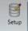in Tool bar.
- Database Setup box will come up.
- Click on down arrow in Create and choose Blank.
- Name the file and save with CVS type.
- Save in C:\Program Data\Bruker\Vision\Database\Your Folder. Click on Save.
- Choose Ra, Rq in Basic Stats and Sequence Number and Time stamp in Meta Data.
- Check Overwrite Current Database. Click Save All.
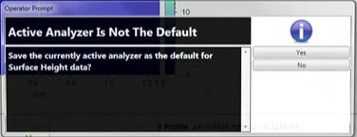. Click Yes.
- Save in C:\Program Data\Bruker\Vision\Recipes\Vision\Your Folder.
- Save the file with (*.visrcp) type. Click on Save.
- Go to Instrument in Menu bar, choose Measurement Setup in Tool bar.
- Choose Auto loop -3- in Settings under Measurement section.
- Click on Measurement on the Tool bar. Wait for progress.
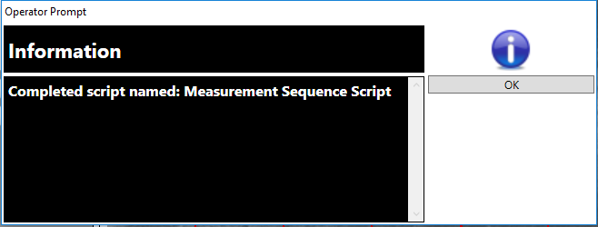 Click OK. You can see all 3 results.

